Applications of LabVIEW for Power Electronics Laboratory
Presented a research paper along with Dr. Gunabalan R & team on integrating LabVIEW into undergraduate power electronics lab experiments @ 11th International Mardin Artuklu Scientific Researches Conference, December 2023, Türkiye
The work involved using NI9225 and NI9227 sensors for real-time voltage and current measurement across AC-DC, DC-DC, and AC-AC converters, with DAQ Assistant blocks handling sensor interfacing. Waveforms were monitored live on the LabVIEW front panel, and measured values were validated against theoretical calculations across varying firing angles.
The purpose of this experiment is to encourage the use of LabVIEW interfacing in universities.

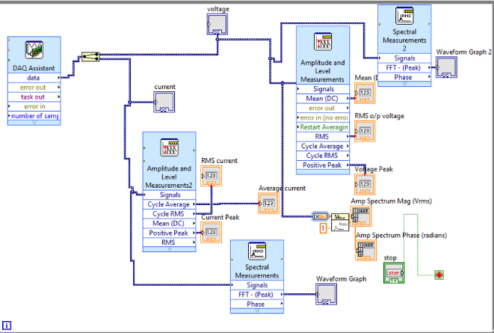
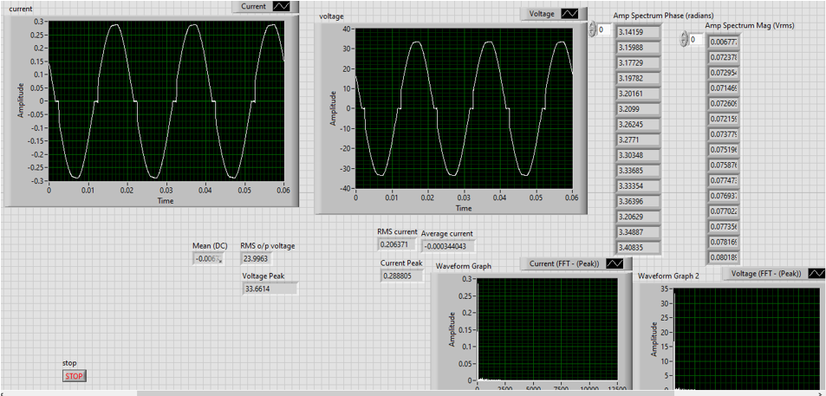
(AC voltage regulator - example)

Certificate: PDF

Team: Dr. R. Gunabalan, Mr. I. Balakumar, Nikhil Mohan, V. R. Aniruth, P. Binu Prasanna.
Conclusion: Demonstrated that LabVIEW-based computer interfacing is an effective and practical approach to modernising power electronics laboratory education.

